Curriculum vitea
RAFAS P.K 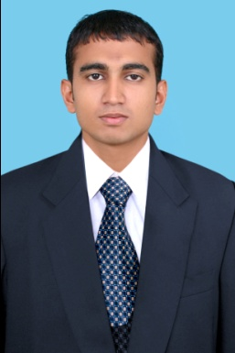
India, Kerala(kannur)
Contact: 8606778767
Email: rafaspk.knr@gmail.com
PROFILE & CAREER OBJECTIVE
Seeking an opportunity to contribute in a challenging position could make best use of my knowledge, skill & value acquired through extensive education & experience.
WORK EXPERIENCE:

1 Year
LULU SARIES
One of the leading Dealers in costume in kannur district, south India worked as customer service cum out door Sales Executive.
1 year
COPIER
One of the leading Dealer in Computer Hardware & Software in Kannur District, south india Worked as a Data Entry Operator cum out door Sales Executive.

EDUCATIONAL ATTAINMENT

- Bachelor of Computer application (BCA)
University of Kannur, Kerala, India.
- Plus two with Commerce
Public Board of Examinations, Kerala, India

Technical qualification:

- Computer Hardware & networking.
(Recognized by government of India)
- CCAN (Cisco Certified Network Associate)
(Recognized by Cisco)
Personal Details:
Date of birth : 26TH February, 1988
Gender : Male
Nationality : Indian
Marital Status : single
Languages Known : English, Hindi, Malayalam, and Tamil.
Permanent address : Fatima’s
Post chirakkal, neerozukumchal
Kannur-670011
Kerala, South India.

DECLARATION:
I Hereby declare that the above mentioned details are true for the best of my knowledge and belief.
RAFAS p.k

